CFIHOS - Implementation Guide for Principal 委托方实施指南

Acknowledgements 致谢
In 2012, Shell approached Netherlands-based process industry organization USPI to explore turning their corporate information standard into an industry-wide standard. The result was the CFIHOS (Capital Facilities Information Handover Specification) project.
壳牌于2012年与总部位于荷兰的流程工业组织USPI（荷兰流程工业协会）接洽，希望将其企业信息标准转化为行业标准，因而形成了CFIHOS（资产密集型设施信息移交规范）项目。
Its aim is to offer practical, standardized specifications for information handover that work across the supply chain – operators, contractors and suppliers. The most recent CFIHOS industry standard (Version 1.4) was published in October 2019 by USPI with support from the Engineering Advancement Association of Japan (ENAA). This document, describing the scope and procedures of CFIHOS, is part of this standard.
CFIHOS项目旨在为信息移交提供实用标准化规范，该规范适用于整个供应链——运行方、承包方和供应方。CFIHOS 1.4版是由USPI在ENAA（日本工程协会）支持下发布的最新版，于2019年10月发布。本文件描述CFIHOS的委托方实施指南，是该标准的一部分。
Following a member vote in 2019, the future governance, development, and maintenance of the CFIHOS project and standard moved from USPI to IOGP in January 2020, becoming Joint Industry Project (JIP) 36.
2019年经成员投票表决，CFIHOS项目和标准的未来治理、编制和维护于2020年1月从USPI移至IOGP（国际油气生产方协会），成为JIP36（第36号联合工业项目）。
Disclaimer 免责声明
Whilst every effort has been made to ensure the accuracy of the information contained in this publication, neither IOGP nor any of its Members past present or future warrants its accuracy or will, regardless of its or their negligence, assume liability for any foreseeable or unforeseeable use made thereof, which liability is hereby excluded. Consequently, such use is at the recipient’s own risk on the basis that any use by the recipient constitutes agreement to the terms of this disclaimer. The recipient is obliged to inform any subsequent recipient of such terms.
尽管已尽一切努力确保本出版物中所含信息的准确性，但IOGP及其任何成员过去现在或未来均不保证其准确性，或无论其疏忽，均不对任何可预见或不可预见的使用承担责任，特此排除这些责任。受方的任何使用均构成对本免责声明条款的同意，因此此类使用的风险由受方自行承担。受方有义务将此类条款通知任何后续受方。
This publication is made available for information purposes and solely for the private use of the user. IOGP will not directly or indirectly endorse, approve or accredit the content of any course, event or otherwise where this publication will be reproduced.
本出版物仅供参考，仅供用户自用。IOGP不会直接或间接认可、批准或授权将复制本出版物的任何课程、活动或其他。
Copyright notice 版权声明
The contents of these pages are © International Association of Oil & Gas Producers. Permission is given to reproduce this report in whole or in part provided (i) that the copyright of IOGP and (ii) the sources are acknowledged. All other rights are reserved. Any other use requires the prior written permission of IOGP.
各页内容版权由IOGP所有（© International Association of Oil & Gas Producers）。在 (i) IOGP的版权和 (ii) 来源得到承认的前提下允许全部或部分复制本报告。IOGP保留所有其他权利。任何其他用途都需要IOGP事先书面许可。
These Terms and Conditions shall be governed by and construed in accordance with the laws of England and Wales. Disputes arising here from shall be exclusively subject to the jurisdiction of the courts of England and Wales.
这些条款和条件应受英格兰和威尔士法律管辖并按其解释。由此产生的争议应仅受英格兰和威尔士法院的管辖。

CFIHOS – Implementation Guide for Principal 委托方实施指南

Version 版本 | Date 日期 | Comments/History 备注/记录
1.4 | April 2020  2020年4月 | IOGP republication of CFIHOS document first published in October 2019.  IOGP对首次于2019年10月发布的CFIHOS文档的再版。
1.4.1 | December 2020  2020年12月 | Minor text changes to Section 3 ‘How to use the CFIHOS Standard on a Project’ - following bug fixes to the CFIHOS Standard to ensure continued alignment.  对“3. 如何在项目上使用CFIHOS标准”的文本的次要变更——更正CFIHOS标准中的错误以确保持续对齐。
1.5 | October 2021  2021年10月 | Minor change correcting spelling error in Figure B-1  对图B-1中拼写错误的次要更正。
1.5.1 | 2022-11  2022年11月 | Minor text changes for bug fixes throughout the text of the document  在本文件的整个文本中更正错误的次要文本变更。

Foreword 前言
The Capital Facilities Information Handover Specification (CFIHOS) is an industry standard developed to improve how information is exchanged between the companies who own, operate, and construct equipment for the process and energy sectors. Starting with a common equipment naming taxonomy and supporting specifications, its goal is to become a common language for the exchange of information in these sectors.
CFIHOS（资产密集型设施信息移交规范）是一项为改进流程与能源行业拥有、运行和制造设备的公司之间如何交换技术信息而制定的行业标准。CFIHOS始于公用设备命名分类法和支持规范，目标是成为流程与能源行业信息交换的公用语言。
The initial focus is on information, both structured data and traditional document formats, which must be handed over when a project moves from its development to operations phase. Ultimately, the aim is for CFIHOS to become the de-facto standard for information exchange throughout the physical asset lifecycle, from vendor information through to decommissioning.
CFIHOS起初关注项目从开发阶段进入运行阶段时必须移交的信息（结构化数据和传统文档格式）。CFIHOS终极目标是成为从供方信息至退役的整个物理资产生命周期信息交换的事实标准。
The Reference Data Library or “RDL” lies at CFIHOS’ heart. This library gives a standard and unified naming convention for equipment, its attributes, disciplines, and documents. The CFIHOS RDL includes:
- A list of classes for Tag and Equipment (what the equipment does and what it is)
- A list of properties (attributes, measures, characteristics etc.)
- Lists of requirements by class (data and document requirements)
- Standard unique coding of data to facilitate digital design and other workflows
- A list of document types
- A list of disciplines.
RDL（参考数据类库）是CFIHOS的核心，为设备及其属性、专业和文档提供一个标准且统一的命名规范。CFIHOS RDL包括：
- 位号和设备的类列表（设备及其功能）
- 特性列表（属性、计量、特征等）
- 按类的要求列表（数据和文档要求）
- 数据的标准唯一编码，以备数字化设计和其他工作流程使用
- 文档类型列表
- 专业列表
At present, CFIHOS covers only the exchange of structured data and documents - not graphical, geometry, and model data. In the future, CFIHOS could be extended to include graphical and design tool and support spare parts procurement, inspection, test requirements, commissioning check sheets, Work Packaging, configuration management, and even drive payment.
CFIHOS目前仅涵盖结构化数据和文档的交换，不涵盖图形、几何和模型数据。CFIHOS未来可能扩展至包括图形和设计工具，并支持备件采购、检验、试验要求、调试检查表、工作包、配置管理，乃至推动支付。
CFIHOS is being developed collaboratively by project members as a practical standard to ensure the systematic and reliable exchange of information between all participants involved in the information supply chain, thereby reducing cycle times and costs. More than 70 organizations contributed to the development of CFIHOS Standard, which is supported by several leading software industry design tools.
CFIHOS由项目成员作为实用标准协作编制，以确保信息供应链中涉及的所有参与方之间系统及可靠的信息交换，从而缩短周期并降低成本。CFIHOS标准参编组织超过70个，并得到一些软件行业领先设计工具支持。

Contents 目次
Foreword 前言 5
1. Introduction 介绍 8
1.1. General 总则 8
1.2. Scope 范围 8
1.3. Target Audience 目标受众 9
1.4. CFIHOS Document Structure CFIHOS文档结构 9
1.5. Terms, Definitions, Acronyms and Abbreviations 术语、定义、首字母缩略词和缩略语 11
1.6. Information Management Principles and Processes in Projects 项目信息管理原则与流程 13
2. Contract Information Requirements 合同信息要求 14
2.1. Contractual Information Requirements Overview 合同信息要求概述 14
2.2. Contract Information Management Scope of Work 合同信息管理工作范围 15
2.3. Contract Information Specification 合同信息规范 16
3. How to use the CFIHOS standard on a Project 如何在项目上使用CFIHOS标准 17
3.1. Specify Information Requirements 规定信息要求 18
3.1.1. Select CFIHOS Contract Scenario Template 选择CFIHOS合同场景模板 20
3.1.2. Identify Additional Project Specific Requirements 确定项目附加特定要求 21
3.1.3. Adjust CFIHOS Template for Local Needs 根据当地需要调整CFIHOS模板 22
3.1.4. Generate Reference Data 生成参考数据 23
3.1.5. Add Reference Data to Specification 将参考数据加入规范 24
3.1.6. Finalize Contract Information Requirements 完成合同信息要求 24
3.1.7. Incorporate in Tender Documents 纳入招标文档 25
3.1.8. Adjustments Due to Bidder Clarification 根据投标人澄清进行调整 26
3.1.9. Finalize Information Specification at Contract Award 在合同授予时完成信息规范 26
3.2. Generate Information Deliverable 生成信息交付物 26
3.2.1. Contractor Actions 承包方行动 27
3.2.2. Principal Reviews and Validates Information Delivered 委托方复核及确认交付信息 28
3.2.3. Principal Returns Comments 委托方返回意见 28
3.2.4. Contractor Incorporates Comments 承包方采纳意见 29
3.3. Handover of Information 信息移交 29
4. Where to retrieve CFIHOS Documents, Tools and Templates 检索CFIHOS文档、工具和模板的地址 30
Annex A: Data, Information, and Documents 附录A 数据、信息和文档 31
Annex B: Contract Scenario Templates 附录B 合同场景模板 32
Annex C: Contract Information Requirements Package – Overview 附录C 合同信息要求包——概述 42
Table of Figures 图表
Figure 1 CFIHOS Document Structure 图1 CFIHOS文档结构 11
Figure 2 How to use CFIHOS on a Project, Overview 图2 如何在项目上使用CFIHOS——概览 19
Figure 3 Process for creating a Contract Information Specification based on CFIHOS 图3 基于 CFIHOS 创建合同信息规范的流程 20
Figure 4 Overview of the CFIHOS templates 图4 CFIHOS模板概览 21
Figure 5 Process for Generating Information Deliverable based on CFIHOS 图5 基于CFIHOS生成信息交付物流程 28

Introduction 介绍

General 总则
This document describes how to implement the Capital Facilities Information Handover Specification (CFIHOS) from a Principal’s (Owner/Operator’s) perspective. This guide does not discuss the expected organizational Information Management (IM) maturity required for effective implementation of the Specification.
本文件描述如何从委托方（业主/运行方）角度实施CFIHOS（资产密集型设施信息移交规范）。本文件不讨论有效实施规范所需预期IM（信息管理）组织成熟度。

Scope 范围
This document describes how to implement the CFIHOS standard:
- Use of the specification in contracts for projects and assets
- How to create a specification for the handover of engineering information between Contractor and Principal that is tailored to the scope of the project or asset
- How to use and adopt the CFIHOS Reference Data Library (RDL)
- How to exchange information.
本文件描述如何实施CFIHOS标准：
- CFIHOS规范在项目和资产合同中的使用；
- 如何根据项目或资产范围，定制承包方和委托方之间的工程信息移交规范；
- 如何使用和采用CFIHOS RDL（参考数据类库）；
- 如何交换信息。
When using this document, it is recommended that the following should be referenced and understood together:
- CFIHOS Specification Document [C-SP-001]
- CFIHOS Implementation Guide for Contractor [C-GD-002]
- CFIHOS Reference Data Library [C-ST-001]
- CFIHOS Data Model [C-DM-001]
- CFIHOS Scope and Procedure [C-TP-001]
- CFIHOS Contract Scenario Templates.
使用本文件时宜一并参考和了解以下：
- CFIHOS规范[C-SP-001]
- CFIHOS承包方实施指南[C-GD-002]
- CFIHOS参考数据类库[C-ST-001]
- CFIHOS数据模型[C-DM-001]
- CFIHOS范围与程序[C-TP-001]
- CFIHOS合同场景模板
For further instructional material on how to read the CFIHOS Data Model, refer to the Data modelling Training Material [C-DM-901] on the CFIHOS SharePoint site.
如何解读CFIHOS数据模型的进一步指导资料见CFIHOS SharePoint站点上的数据建模培训材料[C-DM-901]。

Target Audience 目标受众
This document should be read by:
- Project Managers who are typically accountable for the delivery of project information to the asset
- Engineering or Operations Managers who typically own the information to be specified and handed over
- Project Information Managers and consultants who are typically responsible for specifying the information and implementing the handover process between the various stakeholders, based on the CFIHOS Specification and Reference Data Library
- Personnel who configure IT systems needed to produce, validate or store the data and documents to be handed over.
以下人员宜阅读本文件：
- 通常负责交付项目信息至资产的项目经理；
- 通常拥有规定和移交的信息的工程经理或运行经理；
- 通常负责基于CFIHOS规范和参考数据类库规定信息，并实施不同利益相关方之间移交流程的项目信息经理和顾问；
- 配置生成、确认或存储要移交的数据和文档所需IT系统的人员。

CFIHOS Document Structure CFIHOS文档结构
The documents which form part of and support the CFIHOS standard are organized as shown in Figure 1. This guide, Implementation Guide for Principal, is indicated in the red circle.
构成及支持CFIHOS标准的文档的组织结构见图1，其中红圈指明本文件。
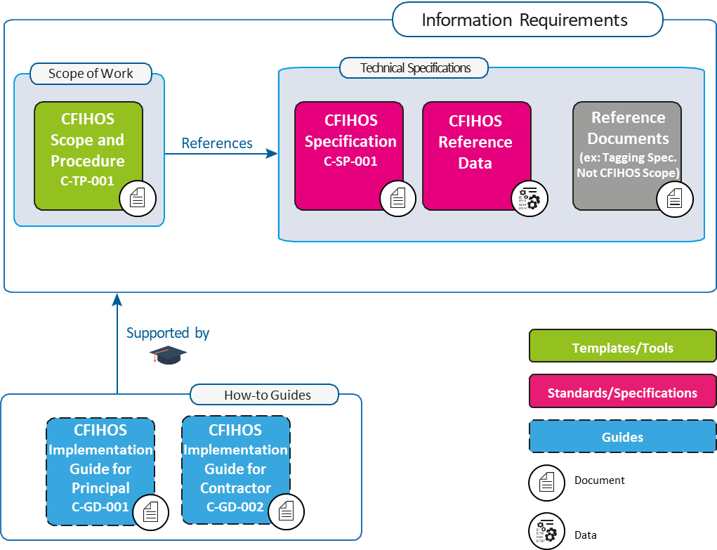
Figure 1 CFIHOS Document Structure
图1 CFIHOS文档结构
It is recognized that Principals may have different ways of organizing their contract documents for Capital Projects. For example, some Principals might include detailed descriptions of requirements within a Scope of Work, whereas others’ Scopes of Work might be a high-level description, with detailed requirements described in separate Specifications and Administration or Coordination Procedures.
公认的是委托方可用不同方式组织资产密集型项目合同文档。例如，一些委托方可能在合同文档中包含对工作范围内要求的详细描述，而其他委托方对工作范围可能为概要描述，详细要求在单独的规范和管理或协调程序中描述。
Another difference is that some Principals collect all of their Information Requirements into a single Information Management Scope of Work, whereas others define Information Requirements alongside requirements for different parts of the Scope of Work.
另一个区别是，一些委托方在单一信息管理工作范围中汇集所有信息要求，而其他委托方则将信息要求与对工作范围不同部分的要求一同定义。
However the Principal chooses to organize its Information Requirements, the following must be included in order to benefit from the CFIHOS standard:
1. “What” information is to be provided.
2. “How” the information is to be provided, including the format (document or data, file type) and how it is to be identified (document type, metadata, data identifier [CFIHOS Unique ID]).
3. “When” the information is to be provided. This is outside the scope of the CFIHOS Specification [C-SP-001], however, the CFIHOS Scope and Procedure [C-TP-001] provides some basic information on this topic.
4. The quality measures that are used to understand the completeness, timeliness, and accuracy of the information. This is not currently addressed by the CFIHOS standard, however, the CFIHOS Scope and Procedure [C-TP-001] provides some basic information on this topic.
为受益于CFIHOS标准，无论委托方如何选择组织信息要求，信息要求必须包括以下：
- 提供“什么”信息；
- “如何”提供信息，包括格式（文档或数据、文件类型）以及如何识别信息（文档类型、元数据、数据标识符[CFIHOS唯一标识符]）；
- “何时”提供信息。此主题不在CFIHOS规范[C-SP-001]范围内，但CFIHOS范围与程序[C-TP-001]提供一些相关基础信息；
- 用于解释信息完整性、及时性和准确性的质量措施。CFIHOS标准目前未涉及该主题，但CFIHOS范围与程序[C-TP-001]提供一些相关基础信息。

Terms, Definitions, Acronyms and Abbreviations 术语、定义、首字母缩略词和缩略语
A complete definition of terms is available in the CFIHOS Specification Document [C-SP-001]. A few key terms used in this document are included below.
CFIHOS规范[C-SP-001]提供完整术语定义。本文件使用的一些关键术语包括以下。
 This symbol identifies important points to consider for the specific section where it is located.
此符号标识其所处特定的条的要考虑要点。
Contract Information Management Scope of Work (IM SoW): In this contractual document the Principal specifies the terms and conditions for information delivery by the Contractor. Where it is applicable and feasible, quality benchmarks and criteria on how the Contractor is to fulfil these requirements may be included. For any details there could be either referred to specific specification documents or included in the scope of work. The term Project Information Management Scope of Work can also be used.
CFIHOS Scope and Procedure document [C-TP-001] is used as a reference to create the project or contract specific Information Management Scope of Work.
IM SoW（合同信息管理工作范围）：委托方在此合同文档中规定承包方交付信息的条款和条件，可在适用且可行的情况下包括关于承包方如何满足这些要求的质量基准和准则。细节可以引用特定规范或包含在工作范围内。也能使用术语“项目信息管理工作范围”。
CFIHOS范围与程序[C-TP-001] 用作创建项目或合同特定信息管理工作范围的参考。
Contract Information Specification (CIS): The resulting document when this CFIHOS industry guideline is applied to a particular project describing the specific set of requirements to be fulfilled. Linked to this document is a Reference Data Library that describes the data characteristics and document types.
The CFIHOS Specification Document is the basis for creating a project or contract specific Information Specification.
CIS（合同信息规范）：将CFIHOS标准应用于特定项目时生成的文档，描述要满足的特定要求集。描述数据特征和文档类型的参考数据类库链接至该文档。
CFIHOS规范[C-SP-001]是创建项目或合同特定信息规范的基准。
Discipline Document Type: An association between Disciplines and Document Class names. In the CFIHOS context, the term Discipline Document Type is a unique identifier for types of documents, which allows deliverables to be specified and content owners to be assigned by discipline. This term has been developed to cater for situations where a document class is common to more than one discipline. For example, a Data Sheet can be produced by different disciplines depending on the nature of the associated equipment.
专业文档类型：专业和文档类名之间的一种关联。术语“专业文档类型”在CFIHOS中是文档类型的唯一标识符，以容许按专业规定交付物并指派内容所有者。该术语为满足一个以上专业公用一个文档类的情况而制定，例如数据表能由不同专业根据相关设备性质生成。
Contractor (EPC Contractor): This is the party that carries out all or part of the design, engineering, procurement, construction, commissioning or management of a project or operation of a facility. The Principal may undertake all or part of the duties of the Contractor.
承包方（EPC承包方）：是执行全部或部分项目设计、工程设计、采购、施工、调试或管理，或设施运行的一方。委托方可承担承包方的全部或部分职责。
Principal (or Owner / Operator): This is the party that initiates the project and ultimately pays for it. The Principal may also include an agent or consultant authorised to act for, and on behalf of, the Principal.
委托方（或业主/运行方）：是发起项目并最终为其出资的一方。委托方还可包括被授权代表委托方并为其行事的某代理方或顾问方。
Prime Contract: This is the main contract for the project/scope of work between the Principal and the Contractor. There might be additional sub-contracts related to the project/scope of work, which must refer to the main contract and its terms and conditions - for example, contracts between contractor and sub-contractors.
主合同：是委托方和承包方之间的项目/工作范围的主要合同。可能有的与项目/工作范围相关的附加分包合同（例如承包方与分包方之间的合同）必须引用主合同及其条款和条件。
Reference Data Library (RDL): Reference Data Library of the metadata of Data and Documents described in CFIHOS Specification Document [C-SP-001]
RDL（参考数据类库）：CFIHOS规范[C-SP-001]所述数据和文档元数据的参考数据类库。
Shall is used to dictate absolute requirements.
应用于指定绝对要求。
Should is used to describe recommendations where noncompliance can be acceptable.
宜用于描述推荐，在此情况下能接受不合规。

Information Management Principles and Processes in Projects 项目信息管理原则与流程
Important Information Management aspects to consider for large engineering projects:
- A Capital Project typically delivers two assets to the Principal organization; a physical asset and an information asset
- Principals are responsible for the specification of the requirements for both the physical asset and the information asset
- The Project Prime Contract contains requirements and terms and conditions for both the physical asset (“Technical Requirements”) and the information asset (“Information Requirements”)
- Contractors, Suppliers/Manufacturers (Vendors) and other third parties are responsible for creating and delivering a high-quality information asset to the Principal, which in turn can be used for Operations and Maintenance
- The information asset will include both Documents (printed or electronic, for human interpretation) as well as Data (stored in a structured format and manipulated using software applications). Annex A further describes Information, Data, and Documents.
大型工程项目要考虑的重要信息管理方面包括：
- 资产密集型项目通常向委托方组织交付两项资产：物理资产和信息资产；
- 委托方负责物理资产和信息资产的要求规范；
- 项目主合同包含物理资产（“技术要求”）和信息资产（“信息要求”）的要求、条款和条件；
- 承包方、供应方/制造方（供方）和其他第三方负责创建并向委托方交付高质量的信息资产。信息资产进而能用于运维；
- 信息资产包括文档（供人解读的纸质或电子文档）和数据（以结构化格式存储，并使用软件应用程序操作）。对信息、数据和文档的进一步描述见附录A。
From a Principal perspective, the information management process involves three steps:
1. Specify the Information Requirements to support both project execution and operations/maintenance activities. CFIHOS seeks to establish a consistent industry standard for such Information Requirements, to make the process of specifying easier and to reduce the cost of the information asset. The overall Information Requirements are contained in the Prime Contract.
2. Control the content to validate that the information generated by Contractors, Suppliers/Manufacturers (Vendors) and others is compliant with the Information Requirements; to track quality, progress and completeness against the Contract Information Specification (CIS). Controls should ideally be executed as closely as possible to the source of information to reduce the time and cost of correcting any issues.
3. Capture, Handover, Use & Share the information asset to optimize its value, e.g. from Suppliers/Manufacturers (Vendors) to Contractors to Principal Project and Asset Operations teams.
信息管理过程从委托方角度涉及3个步骤：
- 规定信息要求以支持项目执行和运行/维护活动。CFIHOS寻求为此类信息要求建立一个一致的行业标准，以使规定信息要求的过程更容易，并降低信息资产成本。总体信息要求包含在主合同中。
- 控制内容以确认承包方、供应方/制造方（供方）和其他各方生成的信息是否遵守信息要求；依据CIS（合同信息规范）跟踪质量、进度和完整性。理想情况下，宜尽可能贴近信息来源执行控制，以减少纠正所有问题的时间和成本；
- 获取、移交、使用和共享信息资产以优化其价值，例如从供应方/制造方（供方）到承包方，再到委托方项目和资产运行团队。
The focus of this guidance is on step 1, i.e. how to use the CFIHOS standard to select and specify Principal’s Information Requirements to Contractors and other parties contracted by the Principal.
本文件聚焦于步骤1，即如何使用CFIHOS标准来选择和规定委托方对承包方和委托方的其他合同方的信息要求。

Contract Information Requirements 合同信息要求

Contractual Information Requirements Overview 合同信息要求概述
A Principal typically has a contracting and procurement process by which a Prime Contract or another contractual vehicle will be agreed with a Contractor to deliver a project scope. The Principal’s Information Requirements need to be included in this Prime Contract or another contractual vehicle, as appropriate.
委托方通常有一个发包和采购流程。委托方通过该流程与承包方商定主合同或其他合同载体，以交付项目范围。此主合同或其他合同载体视情需要包含委托方信息要求。
The objective of the Principal typically is to ensure that the Contractor delivers the minimum set of information required to effectively execute the project and manage its projects and assets. To this end, the Information Requirements need to be articulated and embedded in the Prime Contract.
委托方目标通常是确保承包方提供有效执行项目和管理其项目与资产所需最小信息集，为此需要在主合同中阐明并嵌入信息要求。
These Information Requirements normally consist of the following elements to be created by the Principal (based on the CFIHOS Standard) and contractually mandated to the Contractor via the Prime Contract:
- Contract Information Management Scope of Work (IM SoW), including
  - High-level description of the information (data and documents) that should be delivered, “When”
  - A framework of rules and principles covering the “How” of information exchange and management.
- Contract Information Specification (CIS) providing detailed requirements of “What” information should be delivered and in which format the information should be delivered, including:
  - Reference Data (based on CFIHOS RDL)
  - Reference Documents (ex: Principal’s Transmittal specification, Tagging convention, etc. Not in CFIHOS scope).
这些信息要求通常包含由委托方（基于CFIHOS标准）创建，并通过主合同以合同方式指令承包方的以下要素：
- 合同信息管理工作范围（IM SoW），包括：
  - 宜交付的信息（数据和文档）的高阶描述，“何时”；
  - 涵盖“如何”交换及管理信息的规则与原则框架。
- 合同信息规范（CIS）提供宜交付“什么”信息以及信息宜以何种格式交付的详细要求，包括：
  - 参考数据（基于CFIHOS RDL）；
  - 参考文档（例如委托方传送单规范、标识规范等，不在CFIHOS范围内）。
Depending on the structure of each Principal’s Prime Contract, the contractual requirements covering information management and handover may not necessarily be centralized into a single Information Requirements Package and may be found dispersed throughout the Prime Contract. However, in this guide, the terms “Information Requirements” and “Information Requirements Package” have been used interchangeably as described above.
根据每个委托方主合同的结构，涵盖信息管理和移交的合同要求可不必集中在单一信息要求包中，可分散在主合同中。但本文件如上所述互换使用术语“信息要求”和“信息要求包”。
In addition to the Information Requirements, the complete Contractual Requirements include the Technical Requirements, also containing Scope of Work and Specifications. The Information Requirements will cover the handover of the information asset, while the Technical Requirements cover the physical asset.
完整合同要求除信息要求外还包括技术要求，并包含工作范围和规范。信息要求涵盖信息资产移交，而技术要求涵盖物理资产。
Note: The specification for the internal processes of the Contractor or the Principal is not part of the scope of CFIHOS and are not covered in this document. The Technical requirements for the physical asset are not within the scope of CFIHOS and are also not covered in this document.
注：本文件不涵盖承包方或委托方内部流程规范，这不在CFIHOS范围内。本文件也不涵盖物理资产技术要求，这也不在CFIHOS范围内。

Contract Information Management Scope of Work 合同信息管理工作范围
The Prime Contract’s IM SoW identifies to a Contractor their contractual responsibility to deliver information to the Principal. The IM SOW should also point to the Contract Information Specification which should identify what information is to be delivered and the format of that information.
主合同IM SoW确定承包方向委托方交付信息的合同责任。IM SoW还宜指向合同信息规范，该规范宜确定应交付的信息以及该信息的格式。
The goal of the Contract IM SoW document is to define the scope, processes, interdependencies and acceptance criteria for the exchange and handover of information between Contractor and Principal. It should allow Contractor to understand the expected deliverables, their timing and other success criteria, and it should enable the Principal to monitor the quality and progress of information creation and delivery in a progressive manner before the final handover. In summary, the IM SoW will point to the relevant Contract Information Specification (which identifies what information needs to be delivered in executing a contract). The IM SoW will then also typically define (See CFIHOS Scope & Procedure Document [C-TP-001] for details):
- IM Standards
- Information Lifecycle, principles and security
- Manage Information and Data
- Change Management
- Interface Management
- Data Governance
- IT requirements related to IM
- IM organization and roles
- IM processes, activities, phases and milestones.
合同IM SoW文档目标是为承包方与委托方之间的信息交换和移交定义范围、流程、互依关系和验收准则；宜使承包方有可能领会期望的交付物及其时间安排和其他成功准则；并宜使能委托方在最终移交前，以渐进方式监测信息创建和交付的质量和进度。总之，IM SoW将指向相关的合同信息规范（确定在执行合同时需要提供哪些信息），另外IM SoW通常还将定义以下（详见CFIHOS范围与程序[C-TP-001]）：
- IM标准
- 信息生命周期、原则和安全
- 信息和数据管理
- 变更管理
- 接口管理
- 数据治理
- IM相关IT要求
- IM组织和角色
- IM流程、活动、阶段和里程碑

Contract Information Specification 合同信息规范
The goal of the Contract Information Specification is to define the technical aspects of the Information Requirements, for which CFIHOS forms the basis as outlined below. CFIHOS identifies a full generic “super-set” of information that may be produced in a project. Principals may choose to augment this “super-set” of requirements with their project specific requirements.
合同信息规范目标是定义信息要求的技术方面，CFIHOS构成其基准，概述见下。CFIHOS确定可在项目中生成信息的完整通用“超集”。委托方可选择根据其项目特定要求扩展此要求“超集”。
However, Principals are encouraged to challenge and consider the costs vs. benefits of their additional requirements. In practice, information delivery is phased over time and the information delivery scope is split into individual packages. To facilitate implementation, CFIHOS therefore defines five templates that reflect typical contracting scenarios, and which can be tailored to reflect the scope of information to be delivered by a Contractor. These contract scenario templates are:
- Engineering Procurement Construction (EPC) or Engineering Services Contractor (ESC) scope.
- Front End Engineering and Design (FEED) scope.
- Document Only Scope (incl. Conceptual Engineering, Surveys/Studies, etc.) – for Document-centric projects.
- Package Vendor Scope.
- Standard Equipment Scope.
- Concept Design.
尽管如此，推荐委托方质疑扩展的附加要求并考虑其成本与收益比。信息交付在实践中随时间推移分阶段进行，信息交付范围拆分为单独的包。CFIHOS定义6个反映典型发包场景的模板以备实施，模板能对照承包方要交付的信息范围定制。这些合同场景模板包括：
- EPC（设计、采购与施工）或ESC（工程服务承包方）范围；
- FEED（前端工程设计）范围；
- 仅文档范围（包括概念性工程、调查/研究等）——供以文档为中心的项目使用；
- 成套供方范围；
- 标准设备范围；
- 概念设计范围。
The Contract Information Specification will:
- Provide the definition of Information objects to be delivered as part of the contract scope. This will be based on a CFIHOS template (EPC, FEED, etc.) and further tailored for the project
- Specify the related CFIHOS based Reference Data tailored for the project
- Define the quality validation rules
- Specify the handover format (file formats, database, XML, CSV, # of paper copies)
- Identify supplementary specifications that the Contractor will need to use to complete and deliver the information scope. (For example, templates and configuration files for applications and company or international specs that should be used).
合同信息规范将：
- 定义作为合同范围一部分要交付的信息对象。这将基于某CFIHOS模板（EPC、FEED等）并为该项目进一步定制；
- 规定针对项目定制的基于CFIHOS的相关参考数据；
- 定义质量确认规则；
- 规定移交格式（文件格式、数据库、XML、CSV、纸质拷贝份数）；
- 确定承包方为完成和交付信息范围需要使用的补充规范（例如，宜使用的应用程序，及公司或国际规范的模板和配置文件）。

How to use the CFIHOS standard on a Project 如何在项目上使用CFIHOS标准
This chapter describes how the CFIHOS Standard should be applied to a project. As shown in Figure 2 below:
- Section 3.1 explains how to use CFIHOS to Specify Information requirements - from a commercial and technical perspective - using the example of a “Contract Information Requirements Package” (Annex C – Figure C-1)
- Section 3.2 identifies the key actions the Contractor needs to complete to Generate Information Deliverable based on requirements specified
- Section 3.3 discusses the Handover of Information deliverables in accordance with the requirements.
本章描述宜如何在项目上应用CFIHOS标准，见图2：
- 3.1以“合同信息要求包”（附录C图C-1）为例，从商务和技术角度解释如何用CFIHOS规定信息要求；
- 3.2确定承包方需要完成的关键行动，以基于规定要求生成信息交付物；
- 3.3讨论按要求移交信息交付物。
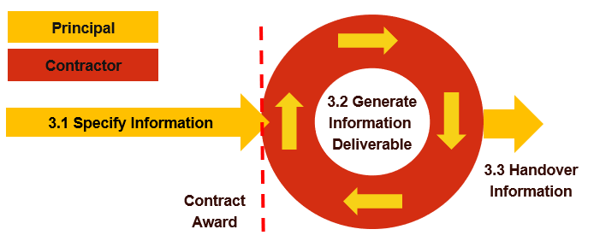
Figure 2 How to use CFIHOS on a Project, Overview
图2 如何在项目上使用CFIHOS——概览

Specify Information Requirements 规定信息要求
The Contract Information Requirements are based on a CFIHOS template that is customised to match the Principal’s Information Requirements and tailored to the scope of the specific contract by the process outlined in Figure 3. The IM SoW is developed in parallel to the CIS as outlined in the processes below. Each process in the boxes of Figure 3 is explained in the following sections 3.1.1 to 3.1.9.
合同信息要求基于CFIHOS模板，该模板经过客制以匹配委托方信息要求，并通过图3中概述的流程针对特定合同范围进行定制。IM SoW与CIS并行制定，如以下概括的流程。3.1.1至3.1.9解释图3方框中的每个流程。

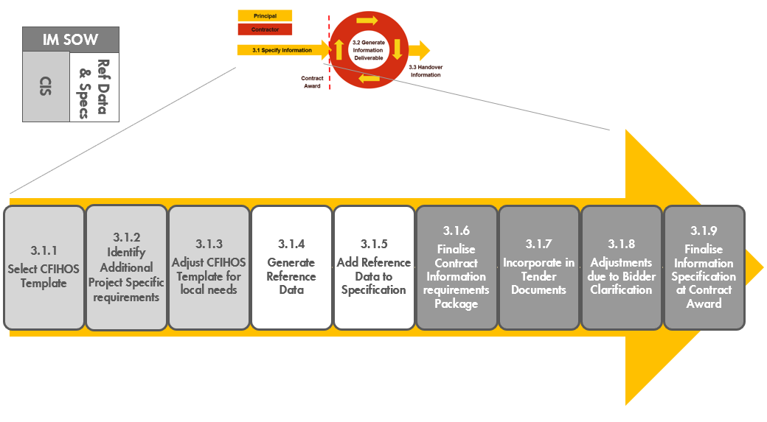
Figure 3 Process for creating a Contract Information Specification based on CFIHOS
图3 基于 CFIHOS 创建合同信息规范的流程
Working through these steps for the first time will take some time, but the generated templates can be reused for future projects, and the deliverables may be re-used in the asset that is created by the project for future Brownfield modifications.
第一次完成这些步骤需要一些时间，但生成的模板能复用于未来项目，且交付物可复用于项目创建的资产，供未来改造使用。
 | As the information requirement in the Contract Information Specification (CIS) needs to be available directly after the contract award, it needs to be unambiguous, and the information structures and naming conventions established for the whole life cycle.  由于需要在合同授予后直接提供CIS（合同信息规范）中的信息要求，因此需要CIS是无二义性的，并为整个生命周期建立信息结构和命名规范。  Before the actual contract award, some pre-qualification, request for a quotation or other similar steps would usually have taken place. This is an opportunity to pre-engage Contractors on the data and document requirements. This gives the Contractor early insight into the Principal’s expectations and gives the Contractor an opportunity to reflect on the availability of any pre-existing CFIHOS application configurations into contract pricing to capture efficiency savings.  在实际授予合同前，通常会有一些资格预审、报价要求或其他类似步骤。这是一个承包方预参与数据和文档要求的机会，使承包方及早了解委托方期望，并使承包方有可能将因任何预先存在且可用的CFIHOS应用程序配置而获取的效率节省反映到合同价格上。  The Information Requirements should include not just information deliverables for Engineering and Construction, but also any requirements that need to be passed from prime Contractors to Vendors or Sub-Contractors  信息要求宜不仅包括设计和施工的信息交付物，还包括需要从主承包方传递至供方或分包方的所有要求。

Select CFIHOS Contract Scenario Template 选择CFIHOS合同场景模板
Select the template that is closest to the project envisaged. There are six templates:
Figure 4 Overview of the CFIHOS templates
图4 CFIHOS模板概览
- Template 1: EPC or ESC
Information specification template containing the Information Requirements to be delivered for an Engineering, Procurement & Construction (EPC) Contract or Engineering Services Contract (ESC) contract scope
- Template 2: FEED
Information specification template containing the Information Requirements for a Front-End Engineering Design (FEED) Contract. In the FEED template, the procurement or delivery of any hardware, and the associated information is considered to be out of scope
- Template 3: Document Only
Information specification template containing the Information Requirements for a Contract delivering documents only. This may include scenarios like Conceptual Engineering, Surveys/Studies and Site Preparation; but could also address projects or assets that are managed in a mainly document-centric way where delivery of structured data is not considered required or useful or where the maturity of the IM organization on the part of the Contractor or Principal does not support data delivery
- Template 4: Package Vendor
Information specification template containing the Information Requirements for engineered equipment packages (i.e. skids, part of a plant), including how to code, format and exchange information (for review and handover) between Contractor and Principal
- Template 5: Standard Equipment
Information specification template containing the Information Requirements for standard (off-the-shelf) equipment purchase orders, including how to code, format and exchange information (for review and handover) between Contractor and Principal.
- Template 6: Concept Design
Information specification template containing the Information Requirements for a Concept Design Contract. In the Concept Design template, the procurement or delivery of any hardware and the associated information is considered to be out of scope.
选择最接近项目设想的模板。有6个模板：
- 模板1：EPC或ESC
包含EPC（设计、采购与施工）合同或ESC（工程服务承包方）合同范围内要交付的信息要求的信息规范模板；
- 模板2：FEED
包含FEED（前端工程设计）合同信息要求的信息规范模板。所有硬件采购或交付以及相关信息不在FEED模板范围内；
- 模板3：仅文档
仅包含文档交付合同信息要求的信息规范模板，可包括概念性工程、调查/研究和场地准备等场景，不过也可能供主要以文档方式进行管理的项目或资产使用，在此结构化数据的交付不是必需或有用的，或承包方或委托方IM组织的成熟度尚无法支持数据交付。
- 模板4：成套设备供方
包含成套设备（即撬装设备、工厂的部分）信息要求的信息规范模板，包括承包方与委托方之间信息编码、格式处理及交换（供复核和移交）方式。
- 模板5：标准设备
包含标准（现货）设备订单信息要求的信息规范模板，包括承包方与委托方之间信息编码、格式处理及交换（供复核和移交）方式。
- 模板6：概念设计
包含概念设计合同信息要求的信息规范模板。所有硬件采购或交付以及相关信息不在概念设计模板范围内。

Identify Additional Project Specific Requirements 确定项目附加特定要求
To augment CFIHOS template requirements, the following additional requirements need to be identified:
- Information requirements not covered by CFIHOS: These may include corporate practices or scope not currently included in CFIHOS. Examples include:
  - Project specific list of document deliverables
  - Engineering Discipline or other technical data in any specific application format
  - 3D Model data in any specific format with specific reference data / Reference documents and catalogues.
- Project Specific reference data/reference documents and specifications: These include taxonomies, object coding and naming conventions that are specific to the project or asset which the Principal expects Contractor to use for labelling or classification purposes
  - Plant Breakdown Structure (Site, Plant, Process Unit, etc.) values to be used for the project
  - Document numbering, tagging, symbols and drawing specifications and rules
  - Any requirements to use any specific software applications (and associated templates) for part of scope
  - Any supplementary Company or International standards, specifications or procedures to be used.
- Brownfield projects may decide to comply with the numbering and classification structure of the original asset, in which case such specific requirements should be included at this stage. A result is a draft Contract Information Specification template that includes Project specific Information Requirements, a pre-defined information model (entities and fields) and relevant reference documents.
要增加CFIHOS模板要求，需要确定以下附加要求：
- CFIHOS未涵盖的信息要求：可包括目前未包含在CFIHOS中的企业实践或范围，例如：
  - 项目特定文档交付物列表；
  - 任何特定应用程序格式的工程专业或其他技术数据；
  - 有特定参考数据/参考文档和元件库的任何特定格式的3D模型数据。
- 项目特定参考数据/参考文档和规范：包括委托方期望承包方用于标识或分类目的的项目或资产特定分类法、对象编码和命名规范；
  - 用于项目的工厂分解结构（场地、工厂、工艺单元等）值；
  - 文档编码、标识、符号和图纸规范和规则；
  - 在部分范围内使用任何特定软件应用程序（和相关模板）的任何要求；
  - 任何要使用的补充公司或国际标准、规范或程序。
- 改建项目可决定遵守原始资产的编码和分类结构，这种情况下宜在此阶段包括此类特定要求，形成一份合同信息规范模板草案，其中包括项目特定信息要求、一个预定义信息模型（实体和字段）和相关参考文档。

 | To derive maximum benefit from information delivery according to the CFIHOS standard, the Principal and Contractor should configure software applications and documents templates using CFIHOS Reference Data and Data Models (for the information covered by CFIHOS). This will ensure consistency across tools and will avoid time-consuming mapping exercises during project execution between CFIHOS and non-CFIHOS based templates by the Principal and the Contractors.  为从按CFIHOS标准交付信息中获得最大效益，委托方和承包方宜使用CFIHOS参考数据和数据模型（针对CFIHOS涵盖的信息）配置软件应用程序和文档模板。这将确保不同工具的一致性，并避免委托方和承包方在项目执行期间在CFIHOS和非CFIHOS模板之间进行耗时的映射工作。

Adjust CFIHOS Template for Local Needs 根据当地需要调整CFIHOS模板
Local needs may be driven by local regulations, such as Document or Data required by local regulations, but which are not part of CFIHOS, such as:
- the need for a specific number of paper copies
- the delivery of quality certificates in specific formats (paper, pdf, etc).
当地需要可由当地法规驱动（如当地法规要求的，但不是CFIHOS一部分的文档或数据），如：
- 需要特定份数的纸质副本；
- 以特定格式（纸质、pdf等）交付质量证书。
The changes identified are incorporated into the project template. Finally, if Principal identifies additional properties which extend beyond those provided in the current version of the RDL, these should also be incorporated into the project template.
在项目模板中纳入确定的变更。最后，如果委托方确定附加特性超出当前RDL版本提供特性，则项目模板宜纳入这些特性。
The result is a draft Contract Information Specification that includes Project specific Information Requirements with a pre-defined information model (entities and fields) and reference documents in compliance with local requirements.
通过以上形成一份合同信息规范草案，其中包括对当地要求合规的，有一个预定义信息模型（实体和字段）和参考文档的项目特定信息要求。

Generate Reference Data 生成参考数据
The Reference Data Library (RDL) is the dictionary that is specified to the Contractor to ensure that consistent naming is adapted for tag/equipment classes, properties, and document types, for use with the Contract Information Specification. The reference data library is a collection of information in a formal manner such that it is suited for (automatically) processing, interpretation, and communication.
RDL（参考数据类库）是规定给承包方的字典，供与合同信息规范一起使用，以确保位号/设备类、特性和文档类型采用一致的命名。参考数据类库是适于（自动）处理、解释和沟通的形式化的信息收集。
The RDL is organized as a series of Comma-Separated Values (.CSV) files containing Object definitions, Tag list, Equipment list, Properties, Units of Measure, Document Types, Pick Lists and any CFIHOS unique identifiers. The CFIHOS Specification document describes the information model that ties the RDL CSV’s together.
RDL由一系列CSV（逗号分隔值）文件组成，包含规定的对象定义、位号列表、设备列表、特性、计量单位、文档类型、值列表和所有CFIHOS唯一标识符。CFIHOS规范描述将RDL CSV连结在一起的信息模型。
The CFIHOS Contract Scenario Templates, described in Section 3.1.1, show the standard expected RDL CSV’s that should be selected for various Capital Project hand-over scenarios.
宜为各种资产密集型项目移交场景选择的标准预期RDL CSV见3.1.1所述CFIHOS合同场景模板。
In this step, the CFIHOS RDL is tailored to specify the reference data that is expected for the specific contract scope. The Principal will need to adjust this information model according to their business requirements and objectives and ensure that the appropriate RDL CSV’s are selected for the Information Specification created.
在本步骤中定制CFIHOS RDL以规定特定合同范围期望的参考数据。委托方将需要按其业务要求和目标调整此信息模型，并确保为创建的信息规范选择适当的RDL CSV。
The Principal may be able to start to populate the template with reference data already available from an engineering information repository/Engineering Data Warehouse that will be utilised to publish the quality checked information during the project. The Principal should also ensure that any software templates to be furnished by the Principal for use by the Contractor are compliant with the RDL.
委托方可启动工程信息储存库/工程数据仓库（将用于在项目期间发布经过了质量检查的信息）中可用的参考数据填充模板。委托方还宜确保委托方配备的供承包方使用的任何软件模板遵守RDL。

Add Reference Data to Specification 将参考数据加入规范
In this step, the Reference Data is added to the information specification per the company business standards. For example, the document default requirements from the CFIHOS RDL need to be updated according to company or project specific requirements, including export control, security classification, document status, and more.
本步骤中根据公司业务标准将参考数据加入信息规范，例如需要按公司或项目的特定要求更新CFIHOS RDL中文档默认要求，包括出口管制、安全分类、文档状态等。
This reference data set can then be attached to the Information Specification. It is recommended to compile each reference data table into a document with a document and version number so that any updates can be re-issued as new versions of the reference data pack.
然后能在信息规范中附上此参考数据集。推荐将每张参考数据表汇编为一份带文档编码和版本号的文档，以便所有更新都能作为参考数据包的新版本重新发布。
Additionally, relevant reference documents should also be attached. These may include: document numbering and control procedures, tagging procedures, other data management procedures, etc.
此外还宜附上相关参考文档，可包括：文档编码和控制程序、标识程序、其他数据管理程序等。
At this point the Contract Information Specification, Reference Data Library, and Reference Documents are complete.
至此合同信息规范、参考数据类库和参考文档已完成。

Finalize Contract Information Requirements 完成合同信息要求
The next step is to complete the IM SoW with additional requirements regarding the frequency of handovers. The timing of delivery of individual sets of information, quality controls and responsibilities for consistency of information across the supply chain should be added.
下一步是完成具有关于移交频次的附加要求的IM SoW。宜添加各组信息的交付时间、质量控制和整个供应链信息一致性的责任。
If milestone payments or other incentives are intended to be used, these need to be defined and aligned with requirements from other disciplines.
如果预期使用按里程碑支付或其他激励措施，则需要对其进行定义并与其他专业要求对齐。
For example, there would be no value in defining a milestone based on the delivery of certain documents if the responsible discipline does not need them until later in the process.
例如，如果负责专业直到流程后期才需要某些文档，那么定义基于交付这些文档的里程碑就没有价值。
This step should ensure that delivery of the required information is specified clearly with the correct timing to meet the needs of different users. For example, equipment information is often targeted for delivery before commissioning but is also often crucial for to the construction contractor for the definition of construction work packages and should ideally be targeted for delivery before construction.
本步骤宜确保明确规定在正确的时间交付要求的信息，以满足不同用户需要。例如设备信息通常以调试前交付为目标，但设备信息常对施工承包方定义施工工作包至关重要，理想情况下宜以施工前交付为目标。
The result of this step is a complete Contract Information Requirements Package consisting of an IM Scope of Work and a Contract Information Specification that is ready for inclusion in the Tender or Contract documentation.
本步骤形成一个完整合同信息要求包，包括一个IM工作范围和一份已备包含在招标或合同文档中的合同信息规范。
 | It is recommended to specify a regular or continuous (e.g. monthly) delivery of data from contractors in the Scope of Work. This allows the Contractor to demonstrate an understanding of the requirements, as well as allowing Principal to test internal data validation systems.  推荐在工作范围规定承包方定期或连续（例如每月）交付数据，这使承包方有可能证实对要求的理解，并使委托方有可能测试内部数据确认系统。  It is important to remember that the Information Requirements Package needs to cover requirements that need to be passed down to equipment suppliers and vendors. Where such requirements cover items that are not covered by the CFIHOS specification, these need to be added to the Information Requirements Package – whether they be reference specifications (e.g. Vendor Document Numbering requirements, Supplier/Vendor Requirements listings etc), or reference data.  重要的是，要记住需要在信息要求包中涵盖需要传递给设备供应方和供方的要求。如果此类要求涵盖CFIHOS规范未涵盖项，则需要将其加入信息要求包，无论是参考规范（例如供方文档编码要求、供应方/供方要求列表等）还是参考数据。

Incorporate in Tender Documents 纳入招标文档
The finalized Contract Information Specification should then be included in the documentation for tendering or other documents for Contractors to ensure a clear understanding of the requirements by the Contractor. This allows feedback on feasibility and costs for delivering information according to the specified requirements. It also enables information management staff to provide project management with a realistic assessment of the bidders’ capabilities and the likely scale (and cost) of any rectification work that may be required so these can be factored into the technical and commercial evaluation.
然后，完稿的合同信息规范宜包含在招标文档或给承包方的其他文档中，以确保承包方清楚理解要求；并可以对按规定要求提供信息的可行性和成本提供反馈；还使能信息管理人员为项目管理提供现实的评定，该评定针对投标人能力和能在技术和商业评估中考虑的可需要的任何整改工作的可能规模（和成本）。

Adjustments Due to Bidder Clarification 根据投标人澄清进行调整
The bidders may return questions, requiring clarification that may result in amendments the IM SOW, CIS, Reference Data or Reference Documents.
投标人可返回问题、要求澄清，这可导致修正IM SoW、CIS、参考数据或参考文档。

Finalize Information Specification at Contract Award 在合同授予时完成信息规范
The Contract Information Requirements Package is finalized for formal transmittal to the Contractors. At this point, any relevant information generated by earlier project phases (for example design information) should also be transmitted to the Contractor, consistent with the formats and rules defined in the Contract Information Specification.
最终确定合同信息要求包，以正式传送单发给承包方。此时项目早期阶段生成的任何相关信息（例如设计信息）也宜以符合合同信息规范中定义的格式和规则传送给承包方。

Generate Information Deliverable 生成信息交付物
Figure 5 is an overview of Generate Information steps, described in sections 3.2.1 – 3.2.4 below.
图5概述生成信息步骤，3.2.1至3.2.4描述这些步骤。
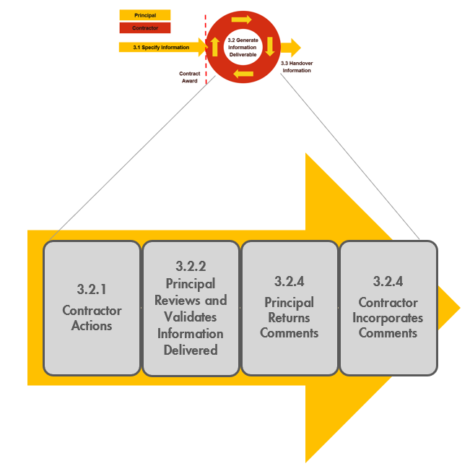
Figure 5 Process for Generating Information Deliverable based on CFIHOS
图5 基于CFIHOS生成信息交付物流程

Contractor Actions 承包方行动
Upon receipt of the Information Requirements, the Contractor would typically engage a Project Information Management organization with adequate skills to coordinate and execute the following steps:
- Review and Confirm understanding of the Information Requirements
- Determine the approach and procedure for changes to the specification
- Identify the sources (providers) of the information
- Ensure project-wide awareness of the requirements for information and quality
- Implement procedures & tools for information collection, validation, and handover
- Collect, validate and consolidate information
- Perform handover to Principal.
承包方在收到信息要求后通常会建立具有足够技能的项目信息管理组织来协调和执行以下步骤：
- 复核并确认对信息要求的理解
- 确定对规范进行变更的方法和程序
- 确定信息来源（提供方）
- 确保项目范围内具备信息和质量要求意识
- 实现信息采集、确认和移交的程序和工具
- 采集、确认和合并信息
- 执行向委托方的移交
These steps are discussed in detail in the CFIHOS Implementation Guide for Contractors.
CFIHOS承包方实施指南详述这些步骤。
The Contractor needs to understand the Information Requirements, deciding how to meet the requirement and then configure internal information systems to comply with CFIHOS. The Contractor also needs to specify CFIHOS compliant deliverables in any sub-contracted work. Typically, the first 6-9 months of this work is most intense, and much effort should be anticipated to get the configuration right and the required sub-contracts in place.
承包方需要理解信息要求，决定如何满足要求，然后配置内部信息系统以遵守CFIHOS。承包方还需要在任何分包工作中规定CFIHOS合规交付物。通常这项工作的前6至9个月最为紧张，宜预计付出许多努力才能完成配置，并落实至要求的分包合同。
Once this is in order, the process of delivery becomes more of an ongoing cycle between the various parties to receive, review and finalize individual information sets, so as continuously complete information delivery.
一旦这些就绪，交付过程就成为各方之间的一个持续循环，以接收、复核和最终确定各个信息集，从而持续完成信息交付。

Principal Reviews and Validates Information Delivered 委托方复核及确认交付信息
Initially, the focus of the Principal is typically to assure that the quality of the information deliverables, and ensure they are compliant with the requirements. Once this aspect is addressed, the focus typically shifts to the monitoring of the progress of the deliverables against the plan. Information is typically on the critical path to project activities such as procurement and construction, and good visibility of delivery against plan can enable early interventions that will keep the project on schedule.
委托方最初的重点通常是保证信息交付物的质量并确保其遵守要求，在处理了这方面后，重点通常会转移至依据计划监测交付物进度。信息通常在采购和施工等项目活动的关键路径上，依据计划交付的良好可见性能使能早期介入以保证项目进度。
The Principal conducts review and validation steps. Pending the priority and criticality of the information delivered, the Principal decides on the thoroughness of control of the information. In case of errors or anomalies, the Principal sends notice to the Contractor for correcting the error, with an indication of the type of the detected error/anomaly.
委托方进行复核和确认步骤。委托方根据交付信息的优先级和关键性决定信息控制的彻底性。如果有错误或异常，委托方通知承包方，指明检测到的错误/异常的类型，供纠正错误。
The correction follows the same process as the initial creation process. The internal approval and review process of the Contractor can be different when processing corrections, this should be defined within the Contractors project quality assurance process and depends on the classification of the error and the priority and criticality of the information.
纠正流程与初始创建过程相同。纠正处理中承包方内部批准和复核流程能有所不同，这取决于错误分类及信息优先级和关键性，宜在承包方项目质量保证流程中定义。
Typically, the Principal runs two parallel review processes, one to address deliverables in document format that is typically reviewed in accordance with a document control process, and a second process to address deliverables in data formats that are typically more of a “back-office” process to ensure data compliance, consistency, and more. Joint reviews of larger data deliverables such as 3D models may also be organized at regular intervals. The results of these parallel reviews are consolidated together for transmittal back to the originator.
委托方通常运行两个并行复核流程，一个流程通常处理按文控流程复核的文档格式交付物，另一个流程通常更像“后台”流程，处理数据格式交付物，以确保数据合规性、一致性等。还可定期组织对更大的数据交付物（如3D模型）的联合复核。这些并行复核的结果会合并在一起，供回传给发起方。
If the information meets all requirements stated in the Contract Information Specification, the Principal formally acknowledges that the information was delivered according to the agreed requirements.
如果信息满足合同信息规范中规定的所有要求，委托方正式认可信息已按商定要求交付。

Principal Returns Comments 委托方返回意见
The Principal returns comments on information delivered back to the Contractor, particularly if any corrections are required. As may be required by the contract, the Principal formally states that the information is accepted as complete, correct and consistent. Due dates can be agreed for this process.
委托方在交回承包方的信息上返回意见，特别是在需要纠正的情况下。委托方可如合同要求，正式声明接受该信息为完整、正确和一致的。能商定此流程截止日期。
 | Note that comments should not be used for managing scope changes. If there is a scope change, the Principal should re-start the process with a change specification.  注：意见不宜用于管理范围变更。如果发生范围变更，委托方宜以变更规范重启流程。

Contractor Incorporates Comments 承包方采纳意见
Pending on priority and due dates set by the Principal, the Contractor pays attention to such comments and incorporate comments to correct Information.
根据委托方设定的优先级和截止日期，承包方重视并采纳意见以更正信息。
 | Note that the quality procedures of the Contractor should cover the process of handling comments received from the Principal. These procedures should include guidelines about review and approval, logging and disposition of the remarks.  注：承包方质量程序宜涵盖处理收到的委托方意见的流程。这些程序宜包括意见复核和批准、记录和处理的指南。

Handover of Information 信息移交
Within a Principal project, multiple Contractors may have been engaged. This would require multiple information management scopes and specifications to be defined and issued to the various contractors to create the full information package/digital twin of the asset being delivered. This information would consequently need to be validated and consolidated within project systems.
可有多个承包方参与同一个业主项目，这将需要定义多个信息管理范围和规范并将其发布给各个承包方，以创建所交付资产的完整信息包/数字孪生。因此需要在项目系统中确认和合并信息。
Typically, the Operations applications used for plant operations and maintenance would be different from those used for Project execution. A system for validation and transformation and loading of the required subset of project collected data will usually be required.
用于工厂运维的运行应用程序通常与用于项目执行的不同，因此需要一个用于确认、转换和导入要求的项目采集数据子集的系统。
A project information handover plan will be in place. This should cover the general scope, role, responsibility, schedule, Quality Control of information to be handed over from project to Operations covering all forms of information (document, data, database/model) from the project team, contractors, and vendors. This plan should also outline how interfaces between various parties (Owner Project team, Contractors, and vendors) will be managed at various stages of the handover process. More details in the CFIHOS Scope and Procedure Document [C-TP-001].
要制定项目信息移交计划，宜涵盖从项目移交给运行的信息的总体范围、角色、责任、进度和质量控制，与来自项目团队、承包方和供方的所有形式信息（文档、数据、数据库/模型）。该计划还宜概述在移交过程各个阶段如何管理各方（委托方项目团队、承包方和供方）之间的接口。更多详细信息见CFIHOS范围与程序[C-TP-001]。
 | Separation of Project and Operate systems (within the Principal environment) is very beneficial for avoiding information conflicts and could help create clear boundaries for managing concurrent/parallel engineering.  （在委托方环境中）分离项目和运行系统非常有益于避免信息冲突，并有助于为管理并发/并行工程创建明确的边界。  Having an Engineering Data Warehouse (EDW) to store Project collected information is essential. Having Extraction, Transformation and Loading tools for moving data from Project to Operate systems is also important to ensure data quality. It is good practice to be 100% as-built for Safety Critical Element information and better than 90% as-built overall at Ready For Start-Up, with final information handover complete within 3 months.  有必要用EDW（工程数据仓库）存储项目采集信息，用ETL（提取、转换和加载）工具将数据从项目移至运行系统，这对于确保数据质量也是重要的。良好实践是开车时已备100%竣工状态安全关键元件信息和总体超过90%竣工信息，最终信息移交在3个月内完成。

Where to retrieve CFIHOS Documents, Tools and Templates 检索CFIHOS文档、工具和模板的地址
All documents relating to the CFIHOS Standard are published on the CFIHOS website and can be downloaded from here.
所有CFIHOS标准相关文档在CFIHOS网站发布，并能下载。

Narrative Documents 说明文件
Scope and Procedures 范围与程序 (C-TP-001)
Specification Document 规范 (C-SP-001)
Implementation Guide for Principal 委托方实施指南 (C-GD-001)
Implementation Guide for Contractor 承包方实施指南 (C-GD-002)

Reference Data Library 参考数据类库
Reference Data Library 参考数据类库 (C-ST-001) – Excel version Excel版
Reference Data Library 参考数据类库(C-ST-001) – CSV zip file CSV zip文件

Data Model 数据模型
Using the Data Model 使用数据模型 (C-DM-001) – Powerpoint version Powerpoint版
Data Dictionary 数据字典 (C-DM-002) – Full version 完全版
Data Dictionary 数据字典 (C-DM-002) – Light version 轻量版

Supporting Templates 支持模板
Contract Scenario Templates 合同场景模板

Annex A: Data, Information, and Documents
附录A 数据、信息和文档

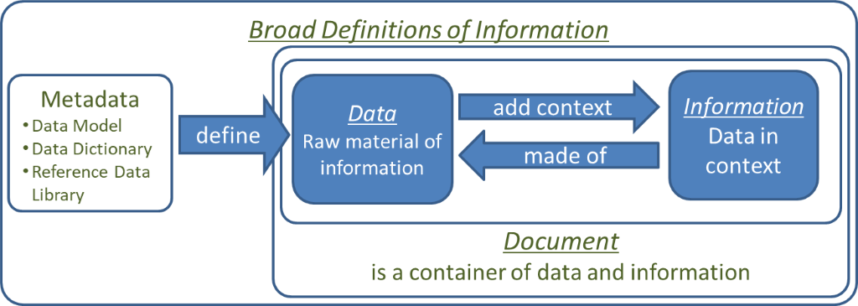

Figure A-1 Data, Information and Documents
图A-1 数据、信息和文档
When Data identifies and describes pieces of information, correspondences or documents including drawings, it is called document metadata. On the other hand, metadata defines data (entities and attributes in relational databases) by their structures (data models), data dictionaries and reference data libraries.
数据在标识与描述信息、通信或文档（包括图纸）时称为文档元数据。另一方面，元数据通过数据结构（数据模型）、数据字典和参考数据类库定义数据（关系数据库中的实体和属性）。
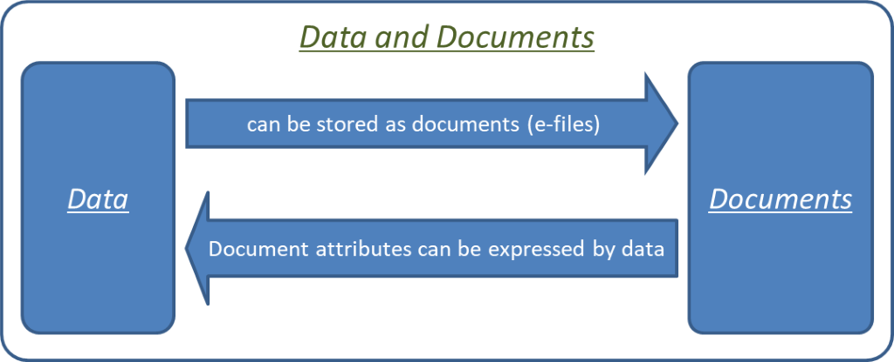
Figure A-2 Data and Documents
图A-2 数据和文档

Annex B: Contract Scenario Templates
附录B 合同场景模板
Here we describe
1) The six scenarios and their definitions
2) The relationship with the CFIHOS RDL
3) The instructions to follow
此处描述：
- 6种场景及其定义
- 与CFIHOS RDL的关系
- 要遵循的说明
1) CFIHOS Handover Scenarios CFIHOS移交场景
The CFIHOS Project delivers five generic information management specification templates. Industry experience shows that these covers more than 90% of potential cases across the lifecycle of a plant. The templates must be customized to produce an information management specification to meet the specific needs of a contract.
CFIHOS项目提供6个通用信息管理规范模板，行业经验表明其涵盖工厂生命周期中90%以上潜在用例。生成信息管理规范必须客制模板，以满足合同的特定需要。
The lifecycle phases that a plant may go through are defined in the CFIHOS RDL Picklist Activity ‘life cycle activity class’.
工厂生命周期阶段定义见CFIHOS RDL值列表——活动“生命周期活动类”。
The asset is not static during operation but undergoes continuous change through a management of change process. For larger changes the same phases apply (brown field project).
资产在运行期间不是静态的，而是经变更流程管理持续变更。较大变更（改建项目）适用相同生命周期阶段。
Templates 模板
The information scope is covered by the following templates:
信息范围由以下模板涵盖：
Template 1: EPC or ESC
Information specification template containing the Information Requirements to be delivered for an Engineering Procurement Construction (EPC) or Engineering Service Contractor (ESC) contract scope. Information requirements would be the same for green field or brown field projects, although volumes will typically be lower for brown field projects.
模板1：EPC或ESC
包含EPC（设计、采购与施工）合同或ESC（工程服务承包方）合同范围内要交付的信息要求的信息规范模板。新建或改建项目的信息要求相同，但改建项目的信息量通常较小。
Template 2: FEED
Information specification template containing the Information Requirements for a Front-End Engineering Design (FEED) Contract. Procurement or delivery of any hardware is out of scope.
模板2：FEED
包含FEED（前端工程设计）合同信息要求的信息规范模板。所有硬件采购或交付不在范围内。
Template 3: Document Only
Information specification template containing the Information Requirements for a Contract delivering documents only. This may include scenarios like Conceptual Engineering, Surveys/Studies and Site Preparation; but could also address projects or assets that are managed in a mainly document centric way, where delivery of structured data is not considered required or useful or where the maturity of the IM organization on the part of the Contractor or Principal does not support data delivery.
模板3：仅文档
仅包含文档交付合同信息要求的信息规范模板，可包括概念性工程、调查/研究和场地准备等场景，不过也可能供主要以文档方式进行管理的项目或资产使用，在此结构化数据的交付不是必需或有用的，或承包方或委托方IM组织的成熟度尚无法支持数据交付。
Template 4: Package Vendor
Information specification template containing the information requirement for packages (i.e. part of a plant), including how to code, format and exchange information (for review and handover) between Contractor and Principal. Typically, the scope is similar to an EPC Contract, but the volumes are smaller.
模板4：成套设备供方
包含成套设备（即工厂的部分）信息要求的信息规范模板，包括承包方与委托方之间信息编码、格式处理及交换（供复核和移交）方式。成套设备合同范围通常类似于EPC合同，但信息量较小。
Template 5: Standard Equipment
Information specification template containing the Information Requirements for standard equipment purchase orders, including how to code, format and exchange information (for review and handover) between Contractor and Principal.
模板5：标准设备
包含标准设备订单信息要求的信息规范模板，包括承包方与委托方之间信息编码、格式处理及交换（供复核和移交）方式。
Template 6: Concept Design
Information specification template containing the Information Requirements for a Concept Design Contract. In the Concept Design template, the procurement or delivery of any hardware and the associated information is considered to be out of scope.
模板6：概念设计
包含概念设计合同信息要求的信息规范模板。所有硬件采购或交付以及相关信息不在概念设计模板范围内。
2) Relationship between the contract scenario templates and CFIHOS RDL 合同场景模板与CFIHOS RDL之间的关系
A spreadsheet illustrating the scope and content of each template is available, see section 4.
说明每个模板的范围及内容的电子表格见第4章。

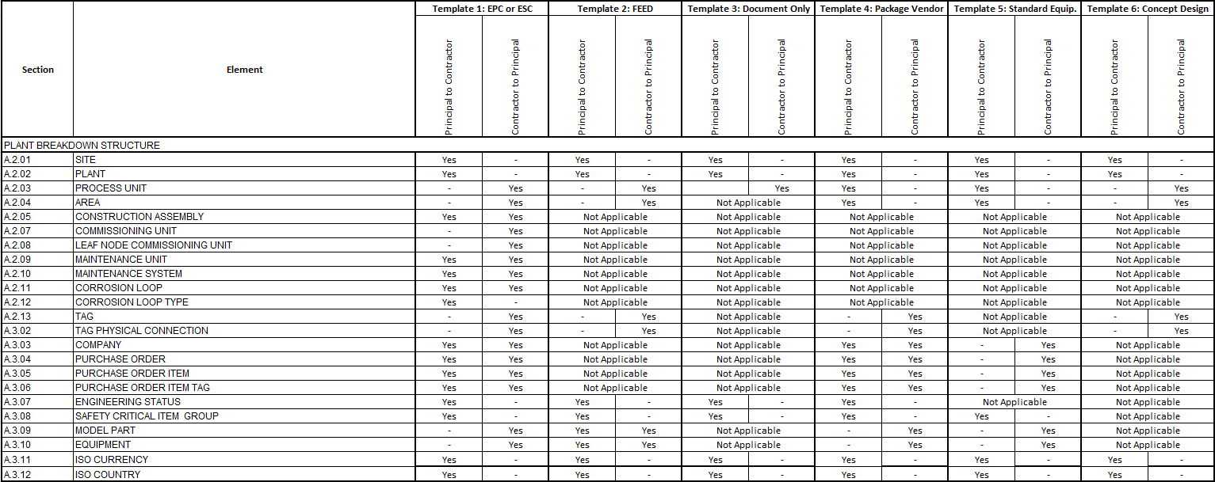
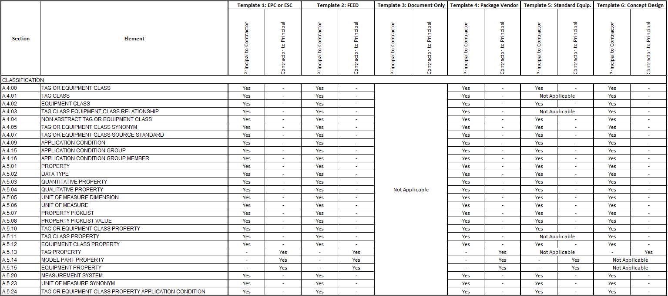
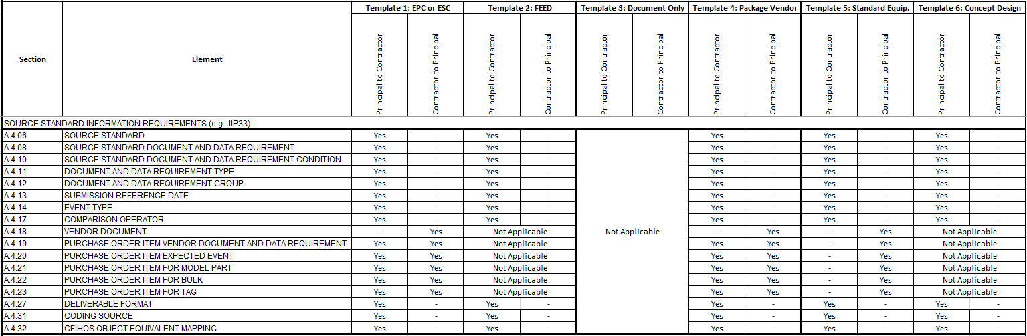
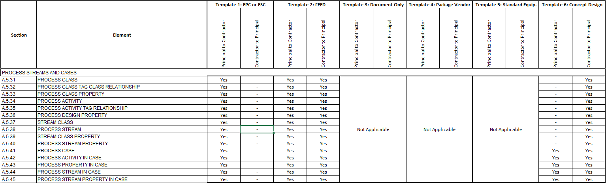
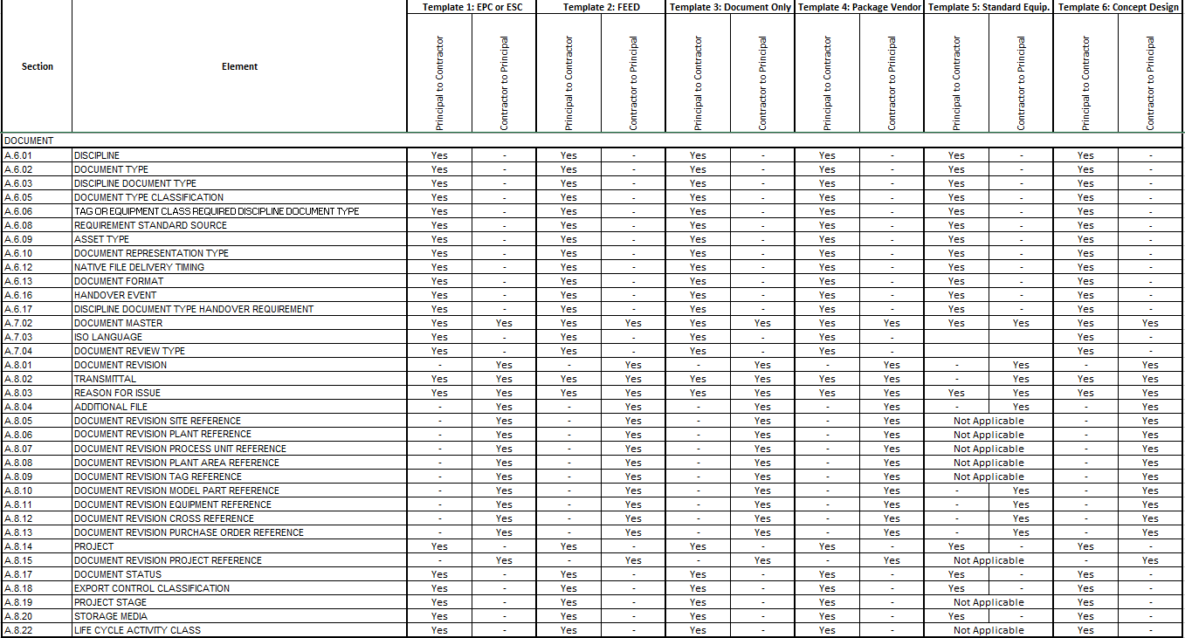
Figure B-1 Scope overview per CFIHOS template
图 B-1 每个CFIHOS模板范围概览
The selected template forms the basis of the draft Contract Information Specification. Copy the template and rename it appropriately according to your company standards and guidelines.
所选模板构成合同信息规范草案基准。复制模板并按委托方公司标准和准则对其进行适当重命名。
The template specifies what information a Principal should deliver to a Contractor (e.g. naming conventions, classifications etc. to be used) and what information the Principal expects to be delivered back by the Contractor (e.g. design data and equipment documentation). Note that this can differ from contractor to contractor even for the same type of information, depending on the capability (maturity) of the contractor, equipment suppliers and the requirements for the exchange of information. The result of this first step is a draft Contract Information Specification template.
该模板规定委托方宜向承包方交付哪些信息（例如要使用的命名规范、分类等）以及委托方期望承包方交回哪些信息（例如设计数据和设备文档）。注意即使对于相同类型的信息也能因承包方而异，这取决于承包方、设备供应方的能力（成熟度）和信息交换的要求。此第一步形成一份合同信息规范模板草案。
 | While each of the CFIHOS templates identifies Plant Breakdown Structure objects that would typically be delivered for the kind of project, consideration should be made for the actual project scope. The scope of a particular project may well alter what is included. For example, if long-lead items are included in a FEED contract scope, the CIS should include the CFIHOS “Equipment” object and its properties – which would be a deviation from the template. As such no CFIHOS PBS object or properties are marked as mandatory to be delivered, what is mandatory for the Contractor to deliver would depend on the specific requirements of a project/asset.  每个CFIHOS模板确定该类型项目通常交付的工厂分解结构对象，但宜考虑实际项目范围，特定项目范围很可能改变所包含的内容。例如，如果FEED合同范围包含长周期物项，则CIS宜包括CFIHOS“设备”对象及其特性——这将偏离模板。因此CFIHOS PBS对象或特性未被标记为必须交付，承包方必须交付的内容取决于项目/资产的具体要求。  Within the definition of the data requirements in the CFIHOS specification, the Principal will need to indicate whether or not the contractor is required to deliver specific attributes. For example, in a FEED Contract, while a Contractor may be required to deliver the Plant Breakdown Structure “Tag” data, this may be limited to only 50% of such Tag properties defined by CFIHOS, because of the project’s particular scope.  在CFIHOS规范的数据要求定义中，委托方需要指明是否要求承包方交付特定属性。例如在FEED合同中，虽然可要求承包方交付工厂分解结构“位号”数据，但由于项目的特定范围，可仅交付50%CFIHOS定义的位号特性。

3) Instructions for usage 使用说明
1. Principal selects a CFIHOS Template. The CFIHOS Template defines the structure of the information to be delivered. Principal needs to decide on the standards to be used.
2. Principal adjusts the CFIHOS Template to create an information specification that reflects the identified business Information Requirements. This may mean removing some elements from CFIHOS as they are not required or adding new elements to satisfy local business requirements.
3. Principal selects the relevant reference data (i.e. classes, properties, document types, etc.) for use with the information specification. Ideally, these will be selected from the CFIHOS RDL but may also include additional company and/or project specific reference data.
4. Principal aligns the reference data with the information specification according to selected business standards. (For example, document type requirements for As-Built documents completed, etc.)
5. Principal finalizes the information specification and the reference data files.
    - 委托方选择一个CFIHOS模板。CFIHOS模板定义要交付信息的结构，委托方需要决定要使用的标准模板；
    - 委托方调整CFIHOS模板以创建反映确定的业务信息要求的信息规范，这可意味着从CFIHOS中删除一些不需要的元素或添加新元素以满足当地业务要求；
    - 委托方选择相关的参考数据（即类、特性、文档类型等），与信息规范一起使用。理想情况下将从CFIHOS RDL中选择，但也可包括附加的公司和/或项目特定参考数据；
    - 委托方按选定的业务标准对齐参考数据及信息规范（例如竣工文档的文档类型要求等）；
    - 委托方确定信息规范和参考数据文件。
Note that the Contractor may return clarifications which may prompt the Principal to amend the information specification or reference data.
注意承包方可返回澄清，这可促使委托方修改信息规范或参考数据。

Annex C: Contract Information Requirements Package – Overview
附录C 合同信息要求包——概述
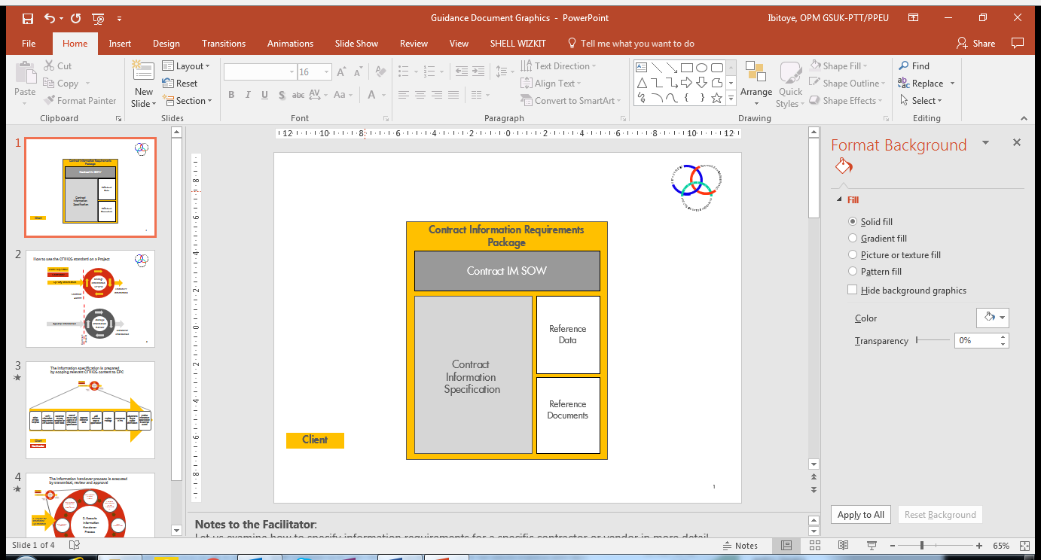
Figure C-1 Contract Information Requirements Package based on CFIHOS
图C-1 基于CFIHOS的合同信息要求包
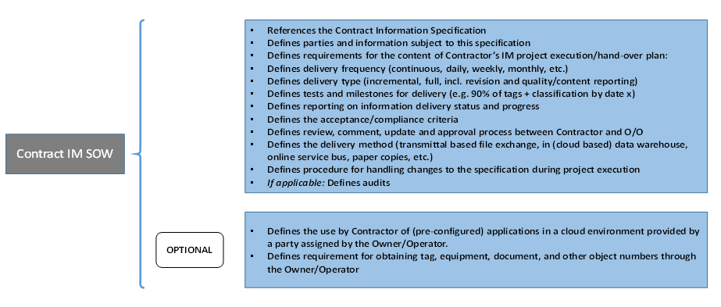
Figure C-2 Contract IM Scope of Work content based on CFIHOS
图C-2 基于CFIHOS的合同IM工作范围内容
Figure C-3 Contract Information Specification content based on CFIHOS
图C-3 基于CFIHOS的合同信息规范内容

